**Assembly Fall 2017 Sec A Lab 07**

**Task 1:**

**Play** power point slides

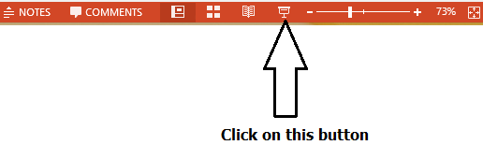

**Task 2:**

Write a program that calculate the following series:

$$ans=\sum_{n=1}^{l}{r^{n}/n}$$

Where r and l are variables. If r =2 and l = 8 then final answer is 4C, but this time you have to make functions. A power function which take base and exponent and then return answer on stack, A divide function that take dividend and divisor and return answer on stack.

**Task 3:**

Write the sub-routine that reverse bits of a number (16 bit number), it accepts a number’s address, and then return reversed number on stack. You are not allow to declare or use any array. For example num = AD5B should be DAB5

# Task 3:

Write the sub-routine to find a number in a sorted array, for this purpose use binary search algorithm. Save location of key in DX. In following code “l” is lower limit of array 0 in start and “r” is upper limit of array length -1 in start and “x” is key.

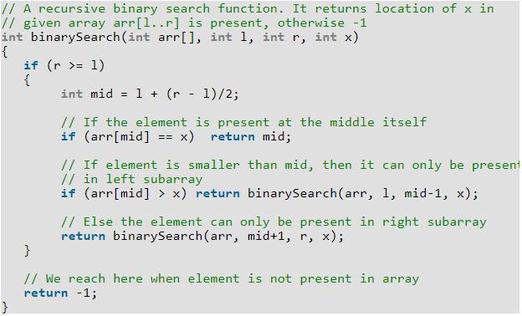

**Task 4:**

A palindrome is a word, phrase, [number](https://en.wikipedia.org/wiki/Palindromic_number), or other sequence of [characters](https://en.wikipedia.org/wiki/Character_(symbol)) which reads the same backward as forward, such as 12321 or 52325.

Write a recursive function that return a value, receive an integer array address, start and end index. It returns 1, if array is palindrome otherwise 0.